Battle of The Neighborhoods – Asian Restaurants Report
Coursera Capstone Project
Mark Stewart

Introduction

The business problem selected for this project is analyzing where a good place to start an Asian restaurant would be. There are many factors in selecting the best location for a new restaurant, however for this project, examining how many restaurants that are in the selected cities and how clustered they are together will be the main factors. The cities that will be looked at further will be New York, NY, Jersey City, NJ, Boston, MA, Chicago, IL, and San Francisco, CA. Of course, there are a lot more factors that go in to determining an ideal new location for a restaurant, like demographic information, neighborhood population density, etc, but for purposes of learning the main objectives from the Coursera classes the two previously mentioned factors were selected.

Data

The data that will be used for this project includes the notebook packages of numbpy, pandas, folium, and requests. These will be used to decipher information from Foursquare, in obtaining the all and the top 100 Asian restaurant venue locations across the 5 previously mentioned cities.

Methods

To start, the first thing that was done was to import all necessary libraries into the IBM Watson Studio jupyter notebook space. Then the cities and the topic of Asian restaurants were selected for the given project. The cities were New York, NY, Jersey City, NJ, Boston, MA, Chicago, IL, and San Francisco, CA. Then the amount of Asian restaurants in total for all cities was determined. This will help determine just how many Asian restaurants there are. Then we want to get a glimpse of just how clustered and compacted the location spots are so we perform a mean distance of the top 100 Asian restaurants.

Results

Here we can see the total number of restaurants for all given cities. We can see that New York has the most and Jersey City has the least amount. The top four appear to be rather clustered going from 315 to 277.

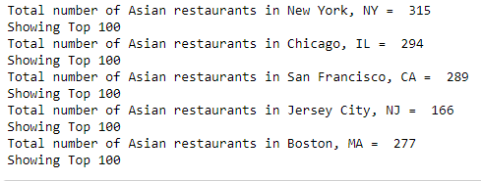
Map of New York

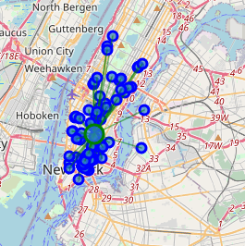

Map of Chicago

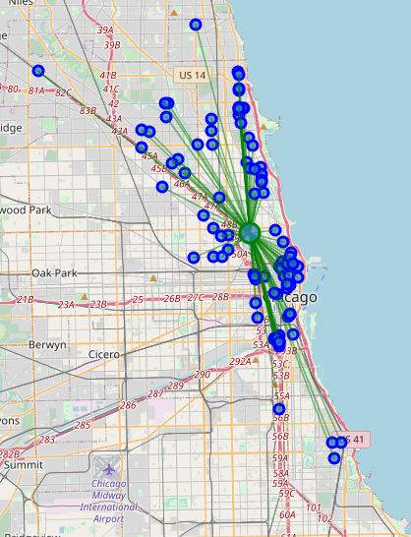

Map of San Francisco

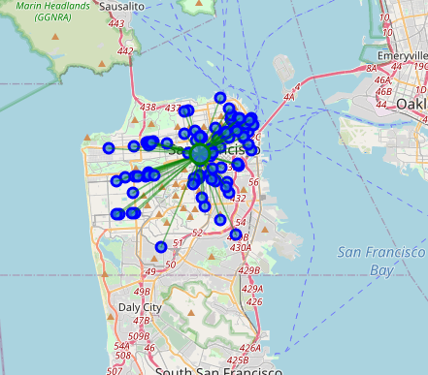

Map of Jersey City

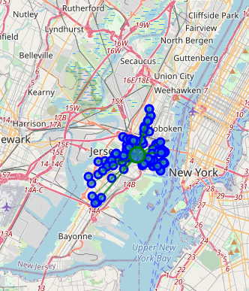

Map of Boston

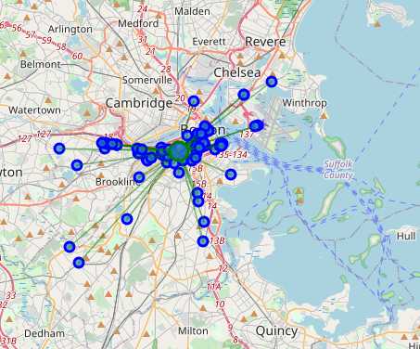

The mean distance from a central city location was taken and reported as follows... with New York and Jersey City having the most densely clustered locations and Chicago having the most widely spread Asian Restaurant locaitons.
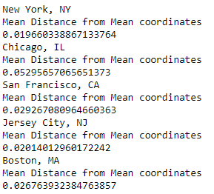

Discussion
When examining all of the results there are some trends that appear to be arising. To start, Jersey City has the fewest amount of Asian Restaurants, with all other cities appearing to have roughly the same amount. However, although, Jersey City has the fewest amount of restaurants, it also is right there with New York in terms of having the least amount of space for a new restaurant/the most dense, clustered restaurants together. Looking at the other densities, Chicago has the most room to put a new Asian restaurant, followed by San Francisco and Boston. Many other factors should be looked at to determine the best locations, variables of socio-demographic factors, population density, and the like should all be considered as well.

Conclusion
In conclusion, New York is the worst spot for a new Asian restaurant. A new location based off the most spread out locations, Chicago would be the best city to put a new Asian restaurant down. It is recommended that further analysis be done on socio-demographics, population density etc. to get the overall best place.

